Project Initialization and Planning Phase

Date | 16 February 2026
Team ID | LTVIP2026TMIDS89357
Project Name | Explore with Ai: custom itineraries for your next journey
Maximum Marks | 2 Marks

Define Problem Statements (Customer Problem Statement Template):
Planning a trip can be time-consuming and overwhelming for travelers, especially when they must search across multiple platforms to find destinations, accommodations, and activities that match their preferences. Many travelers struggle to create personalized itineraries that fit their interests, budget, and schedule. This leads to frustration, confusion, and uncertainty during the planning process.
To improve the travel planning experience, it is important to understand travelers’ needs, preferences, and pain points. By using AI to provide personalized recommendations and automatically generate custom itineraries, we can simplify the planning process, save time, and create a smooth, enjoyable experience. This will help travelers feel confident, supported, and excited about their journey while building trust and satisfaction with the platform.
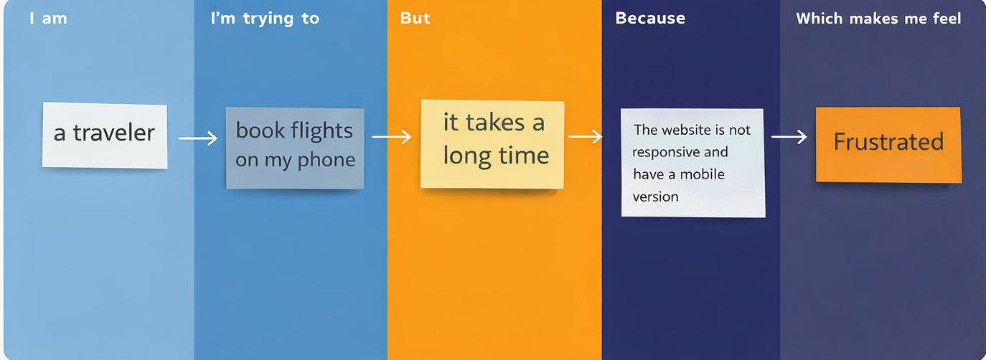
Problem Statement (PS) | I am (Customer) | I’m trying to | But | Because | Which makes me feel
PS-1 | a traveller | book flights on my phone | it takes a long time | information is scattered and not personalized | frustrated

